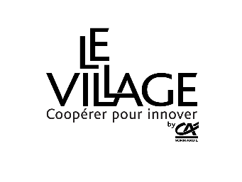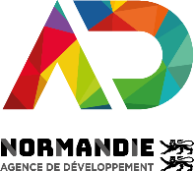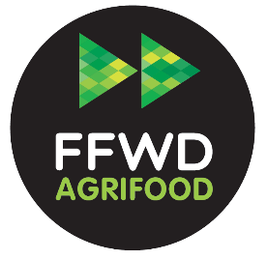

**APPLICATION FORM**

**FAST FORWARD AGRIFOOD**

**Season #3**

As an extension of the Fast Forward Accelerator (FFWD), AD Normandie and the Village by CA Normandie coordinate an acceleration programme specific to the agricultural and agri-food sectors: AgTech and FoodTech.

This scheme is aimed at start-ups with innovation projects in Normandy or in connection with the region (R&D projects, subcontracting, industrial partnerships, etc.).

This form must be completed so that your application can be taken into account.

Sending this application form implies unreserved acceptance of the regulations (available on ffwdnormandie.com or on request by e-mail to lucie.latour@adnormandie.fr) of which the applicants certify having read.

In order to study your application, you may be asked to provide additional information at a later date, in particular:

* Organisation chart / capitalisation table of the company
* KBIS
* Forecast accounts
* Balance sheets for the last 3 fiscal years
* manager's CV

**File to be sent to rose-marie.tostivint@adnormandie.fr or to be completed on www.ffwdnormandie.com.**

**before October 17th 2022**

For information, you can contact :

**Laure LECLERCQ**

Manager

Fast Forward Normandie

[laure.leclercq@adnormandie.fr](mailto:laure.leclercq@adnormandie.fr)

+332.50.53.10.93 - +337.88.44.93.84

**Rose-Marie TOSTIVINT**

Project Manager

Fast Forward Normandie

rose-marie.tostivint@adnormandie.fr

+332.31.15.81.50 - +336.84.15.07.51

**Céline VINCENT**

Start-up Manager

Village by CA Normandie

celine.vincent[@levillagebyca.com](mailto:guillaume.berranger@levillagebyca.com)

+336.38.20.73.31

Contact (name/first name) :

Function in the company :

Tel :

Mail :

**1_ Your company**

|  |  |
| --- | --- |
| trade name :  Field of activities :  Adress:  Country :  Website : | Creation date :  Capital:  Legal forme :  Employees  : |

Group membership :  yes  no

> If yes: group size (consolidated headcount):

Distribution of capital :

|  |  |
| --- | --- |
| Shareholders  (individual or legal entity) | Percentage |
|  |  |
|  |  |
|  |  |
|  |  |

**2_ Project :** origin, concept, stage of development, value proposition

|  |
| --- |
|  |

**3_ Product / Offer :** main features, technical characteristics, innovation, competitive advantage, intellectual property

|  |
| --- |
|  |

**4_ Business model**

|  |
| --- |
|  |

**5_ Market** : size, stakeholders, competition

|  |
| --- |
|  |

**6_ Clients :** targets, distribution channels…

|  |
| --- |
|  |

**7_ Team :** management team, distribution of roles, skills

|  |
| --- |
|  |

**8_ Growth & funding**

|  |  |  |  |  |
| --- | --- | --- | --- | --- |
|  | **2018** | **2019** | **2020** | **2021** |
| **realized** | **realized** | **estimated** | **estimated** |
| **Financal year duration (in months)** |  |  |  |  |
| **Sales Revenue (K€)** |  |  |  |  |
| **EBITDA (en K€)** |  |  |  |  |
| **Working capital requirements (K€)** |  |  |  |  |
| **Equity (K€)** |  |  |  |  |
| **Cash flow (K€)** |  |  |  |  |
| **Employees** |  |  |  |  |

**Fundraising activities (date, amount, investors):**

|  |
| --- |
|  |

**Financing needs and sequencing (N, N+1, N+2,...):**

|  |
| --- |
|  |

**Request for financing proposed by Normandie Participations and its co-investor Crédit Agricole Innove en Normandie (up to €150k):**  yes  no

**9/ Needs for support**

**Have you ever been accompanied by other structures?**

yes  no

**if so, which ones?**

|  |
| --- |
|  |

**Why do you want to join the Fast Forward Agrifood program (support, financing, experimentation, others...)?**

|  |
| --- |
|  |

**What are your expectations and needs in terms of industrial or research partnerships?**

*What solution do you wish to experiment with, with what type of partners, over what period of time?*

|  |
| --- |
|  |

**Would you like to be hosted in the Village by CA Normandie during the acceleration period?**

yes  no

AD Normandie is committed to guaranteeing the confidentiality and security of your data, in accordance with the General Data Protection Regulation (EU) 2016/679 of the European Parliament (RGPD) and of the Council of 27 April 2016 on the protection of individuals with regard to the processing of personal data and on the free movement of such data, and with Law No. 78-17 of 6 January 1978, as amended, known as the "Informatique et Libertés" law.  
The data collected is recorded in a computerized file by AD Normandie, represented by its President and Data Controller, Hervé Morin. The legal basis for this processing is consent (you are free to join the scheme) and also the public interest mission.

The data collected will be communicated only to the members of the selection committee and will be kept for eighteen months for the candidates, and will be integrated into the AD Normandie's company database for the winners.  
You can access your personal data, rectify it, request its deletion or exercise your right to limit the processing of your data. Consult the cnil.fr website for more information on your rights.

To exercise these rights or for any question about the processing of your data in this system, you can contact: Data Protection Officer - 2 ESP ANTON PHILIPS 14460 COLOMBELLES - E-mail: dpo@normandie.fr

If you consider, after having contacted us, that your rights "Data processing and Freedoms" are not respected, you can address a complaint to the CNIL.